Artificial Intelligence Lab

Lab Manual 06



Department of Cyber Security

HITEC University Taxila

1. Introduction
In Artificial Intelligence (AI), agents perceive and act upon their environment. This lab manual focuses on the simplest type of intelligent agent: the Simple Reflex Agent. Students will learn the theory and implement it in Python.

2. Objectives
- Understand the concept of agents in AI
- Explore the working of simple reflex agents
- Implement a simple reflex agent in Python
- Analyse its strengths and limitations
Software
- Python, Pycharm or VS-Code IDE

3. Theory

3.1 What is an Agent?
An agent can perceive its environment through sensors and act upon it through actuators. An AI agent is a software or hardware entity that performs actions autonomously to achieve specific objectives. It operates by perceiving its environment, processing information, making decisions, and taking actions based on its perceptions and goals.
Agent = Sensors + Actuators
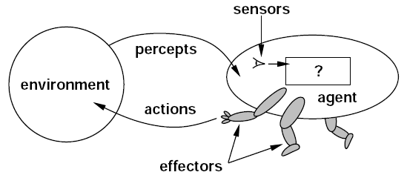

3.2 The Components of an Agent
An AI agent typically consists of three main components:

1. Sensors:
Sensors are responsible for perceiving the agent's environment by collecting data and information. They serve as the input devices of the agent, allowing it to gather information about the world. Sensors can be physical sensors like cameras, microphones, or temperature sensors, or software-based interfaces for collecting data from digital sources, such as databases or web APIs.

2. Actuators:
Actuators are responsible for taking actions in the agent's environment based on the information and data received through sensors. Actuators serve as the output devices that enable the agent to interact with and affect the external world. Examples of actuators include motors, speakers, displays, and software components that can control other software or hardware devices.

3. Internal Function:
The internal function, also known as the agent's decision-making or reasoning component, processes the data collected by sensors, makes decisions based on this data, and generates actions to achieve the agent's goals. The agent's intelligence resides in this component, involving algorithms and mechanisms for problem-solving, planning, and learning.

3.3 Types of Agents:
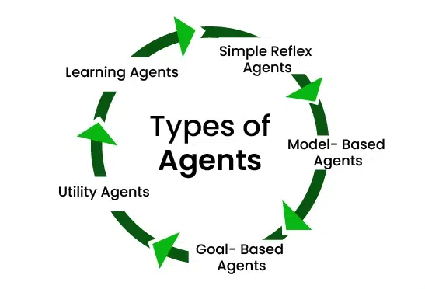

3.4 What is a Simple Reflex Agent?
A simple reflex agent is an AI agent that makes decisions based only on what’s happening in the environment. It works according to the condition-action rule or a simple ‘IF…THEN’ statement.
It doesn’t worry about the percept history or future consequences. It’s all about the current sensory information from the environment.

Working mechanism:
When the learning agent gets new information from its surroundings, it checks a set of rules to see if anything matches.
- If yes, the action is executed
- If not, the agent does nothing
As the name suggests, it’s more like an instinctive, immediate, and straightforward reflex. A Simple Reflex Agent acts only based on the current percept (input from the environment), ignoring the rest of the percept history.
It follows a condition-action rule:
If condition, then action
Agent Function vs. Agent Program
- Agent Function maps percept sequences to actions.
- Agent Program implements the function in code.

3.5 Python Implementation
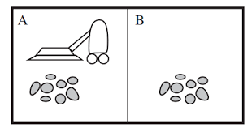
Example Scenario: Vacuum Cleaner World
- Environment: Two rooms (A and B)
- Each room may be Clean or Dirty
- The agent can:
  - Move Left or Right
  - Vacuum dirt if present
Rule Table
Percept | Action
(A, Dirty) | Vacuum
(B, Dirty) | Vacuum
(A, Clean) | Right
(B, Clean) | Left

Code:
class Environment:
def __init__(self):
self.rooms = {'A': 'Dirty', 'B': 'Dirty'}
self.agent_location = 'A'

def get_percept(self):
return self.agent_location, self.rooms[self.agent_location]

def execute_action(self, action):
if action == 'Vacuum':
self.rooms[self.agent_location] = 'Clean'
elif action == 'Right':
self.agent_location = 'B'
elif action == 'Left':
self.agent_location = 'A'

class SimpleReflexAgent:
def __init__(self):
self.rules = {
('A', 'Dirty'): 'Vacuum',
('B', 'Dirty'): 'Vacuum',
('A', 'Clean'): 'Right',
('B', 'Clean'): 'Left'
}

def select_action(self, percept):
return self.rules.get(percept, 'NoOp')

# Simulation
env = Environment()
agent = SimpleReflexAgent()

for step in range(5):
percept = env.get_percept()
action = agent.select_action(percept)
print(f"Step {step + 1}: Percept: {percept}, Action: {action}")
env.execute_action(action)

Output:
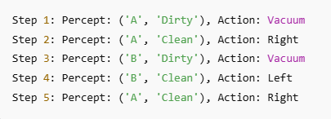

Code Walkthrough
- Environment represents the rooms and dirt status.
- SimpleReflexAgent uses condition-action rules.
- The simulation runs for 5 steps.
Let’s say this is the situation at the start:
- Room A: Dirty
- Room B: Dirty
- Agent is in Room A
Step 1:
- Percept = ('A', 'Dirty') → Action = 'Vacuum'
- Result: Room A becomes Clean
Step 2:
- Percept = ('A', 'Clean') → Action = 'Right'
- Result: Agent moves to Room B
Step 3:
- Percept = ('B', 'Dirty') → Action = 'Vacuum'
- Result: Room B becomes Clean
Step 4:
- Percept = ('B', 'Clean') → Action = 'Left'
- Result: Agent moves back to Room A
Step 5:
- Percept = ('A', 'Clean') → Action = 'Right'
- Result: Agent moves back to Room B

4. Lab Task
- Do these tasks:
  - Modify the environment to add a third room.
  - Make the agent move randomly when both rooms are clean.
  - Add a counter to track how many times the agent cleaned.
- Design a rule-based reflex agent for a smart light system.
- Simulate a thermostat agent that maintains room temperature between 20°C and 24°C using internal memory (model of past temperatures):
- An agent can sense the current temperature.
- It must remember the past few temperature values (model) to predict if heating/cooling is needed.
- If the temperature trend is rising or falling rapidly, take preventive actions.

5. Conclusion

